Using Zahara
Construction Company with Sage 50

How it works

Purchase Control

In-house Buyer:
One person or one team does the buying. They maintain the supplier list in Zahara and can create or import products and update pricing regularly. When the “field” want materials, they call it through to the buyer. The buyer then raises the order, which results in a PO going off to the supplier or could simply result in the order being placed online.
Zahara’s workflows can be used to trigger approvals under different circumstances, such as a price being over a certain threshold or a pre-set budget being breached.

Mobile app:
The mobile app allows buying “in the field”. There are two types of order. A full order – the same as using Zahara on a full-size device and a Quick Order. The Quick Order is designed for Trade Counters. The buyer relays his order. At the point of completion, he generates a purchase order number and gives it to the trade counter guy. The paperwork is printed out – the collection note – your buyer can take a photo of this and it is saved with the order. Now finance have an immediate visual on this purchase.

Project Managers / Foremen
If you have PMs or Foremen doing the buying, then they can use Zahara on any device to raise their orders. You can control the buying process using the workflows and user permissions.

Budgets & Projects

Budgets can be used to create frameworks for buying. You can create a Budget and assign it to either a Division or Project in Zahara. Budgets will show you how you are doing on that project and can be used to control spend. You can progress the spend against the budget in the Project.
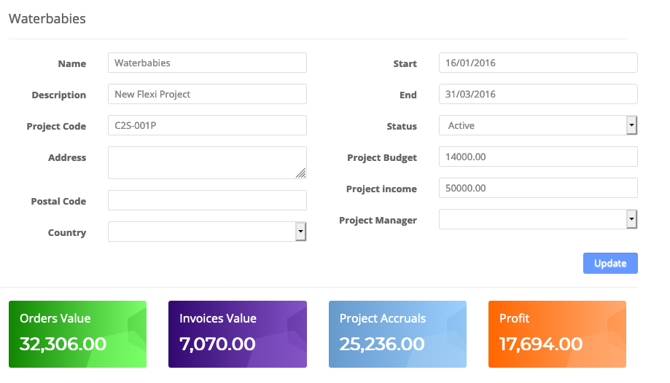

Projects are designed for people in construction so that you can allocate spend to the correct job. You can see the progress of a Project. You can record the income figure to provide an overall profit but take into account that other costs don’t hit Zahara, like payroll and depreciation. Project Managers can be assigned and used in approvals. The design here is for you to answer the question “how much have we spent so far on X”.
Finance Team

Making AP faster and easier

If you are using the control side of Zahara, then all spend will be recorded as it is being made. You now have a database of all requests and the audit trail behind every purchase. Now when an invoice comes into the business, you should know about it. With Zahara’s invoices you can

- Record stand-alone invoices
- Record invoices that can be matched against corresponding orders
- Send any invoices out for approval – automatically or on an Ad Hoc way
- Export invoices into Sage 50
- Accrue for invoices in Zahara, not yet in Sage 50

How it can work

- Generate an email address in Zahara for your invoices – ie mycomoany@zaharamail.com
- Make sure all suppliers send invoices to this email address – add instructions to your purchase order and bulk email all your other suppliers – tell them how it needs to be
- Process invoices from within the Invoices Inbox in Zahara
- Have invoice workflows that include automatic exporting of invoices to Sage 50 on approval.
- Work on the disputed invoices – let the approved one’s flow into Sage 50
- Pay your suppliers from Sage 50

Reporting

Zahara search allows you to search easily for invoices, orders, suppliers or detail inside the line items. We can answer questions like “who do we buy C8-80-15 from?” very easily. Just search for it.
You can also run any reports you need. At month end you can run an invoice / order difference report or one of the accruals reports. Our reporting allows you to set your criteria and then send yourself a spreadsheet to manipulate.
Permissions

Each user can have a separate permission set to allow them to see or do different things. Generally, finance staff have access to everything – although you can control who exports invoices – and buyers can be restricted right down. The Divisions in Zahara act as the user groups – you assign users to a Division and they buy against that Division and therefore the workflows and approvals in that Division are pre-set so you get the desired outcome you need for every purchase and every invoice.

How to deploy Zahara

- Create your Business Unit and the Divisions you think you need
- Install SmartSync and pull in all your data from Sage 50 – suppliers, coding & projects.
- Create an assign your users – set basic permissions for now
- Create some workflows – follow the guides / videos
- Create your invoices email address for the invoice inbox
- Set your Purchase Order template and add the new email address to the invoice instructions
- Run some test purchases and get them approved
- Test your approvals
- Test to see what your PO PDF looks like
- Record and match an invoice against your Invoice
- Export an invoice into Sage 50 (via SmartSync)*
- Advise all suppliers “this is how it will be”
- Set Budgets and assign to Divisions or Projects
- Go live

* SmartSync considerations
SmartSync has a huge amount of settings to help you fine-tune your Zahara & Sage 50 setup. The most important things are:

- Coding alignment – are you populating your Department ID’s with the correct value from Zahara – you have a choice of Division ID, Cost Code & Project Code.
- Line Items consolidation – Do you want to have every line item in Zahara recorded within the invoice in Sage 50 or do you want to consolidate down to the same Nominal Codes?
- Narrative – if you are consolidating line items, how do you want the Narrative / description line populated in Sage 50
- Document Links – Zahara will be the place the Invoice PDF is stored for ever and a day. Do you want to pull down a local copy as well?

SmartSync can do all of the above and more and this is all in the settings.

Resources

The Zahara Knowledge Base has everything answered for you. There are sections for Zahara, SmartSync and SmartInvoice. Some of the help guides have videos as well.

https://help.zaharasoftware.com

Mobile App Setup
https://help.zaharasoftware.com/portal/kb/articles/mobile-app-overview

Other Add Ons

Document Management – You can link Zahara to a third-party document management system called FileDirector – www.filedirector.com – FileDirector is available on-premise or in the cloud and is the perfect platform to help you become paperless or at least less paper.

Invoice OCR Processing – We have two different desktop PC applications that can be used to scan or load invoices, have them recognised and matched and exported into Zahara. SmartInvoice is the most accessible and easiest to setup and deploy. ABBYY FlexiCapture is the most sophisticated and scalable application available.

